23.40: For points outside this spherical charge distribution the field is the same as if all the charge were concentrated at the center.
Therefore
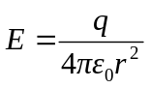
and
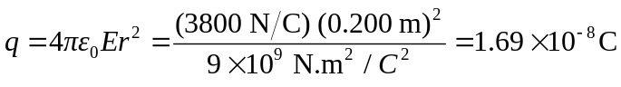
Since the field is directed inward, the charge must be negative. The potential of a point charge, taking as zero, is
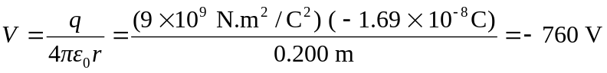
at the surface of the sphere. Since the charge all resides on the surface of a conductor, the field inside the sphere due to this symmetrical distribution is zero. No work is therefore done in moving a test charge from just inside the surface to the center, and the potential at the center must also be 